**DAILY ONLINE ACTIVITIES SUMMARY**

|  |  |  |  |  |  |  |  |  |
| --- | --- | --- | --- | --- | --- | --- | --- | --- |
| **Date:** | **22-6-2020** | | | | | **Name:** | **poojashree** | |
| **Sem & Sec** | **8th sem A sec** | | | | | **USN:** | **4al16cs065** | |
| **Online Test Summary** | | | | | | | | |
| **Subject** | | **sms** | | | | | | |
| **Max. Marks** | | **---** | | **Score** | | | **---** | |
| **Certification Course Summary** | | | | | | | | |
| **Course** | **Introduction to cyber security** | | | | | | | |
| **Certificate Provider** | | | **Great learning academy** | | **Duration** | | | **5.5hr** |
| **Coding Challenges** | | | | | | | | |
| **Problem Statement:**  1.**Python program to convert first and last letter of string to Upper-Case** | | | | | | | | |
| **Status:completed** | | | | | | | | |
| **Uploaded the report in Github** | | | | | **yes** | | | |
| **If yes Repository name** | | | | | **Poojashree** | | | |
| **Uploaded the report in slack** | | | | | **yes** | | | |

**Online test**

**----------marks not yet received-----------**

**Certification course**

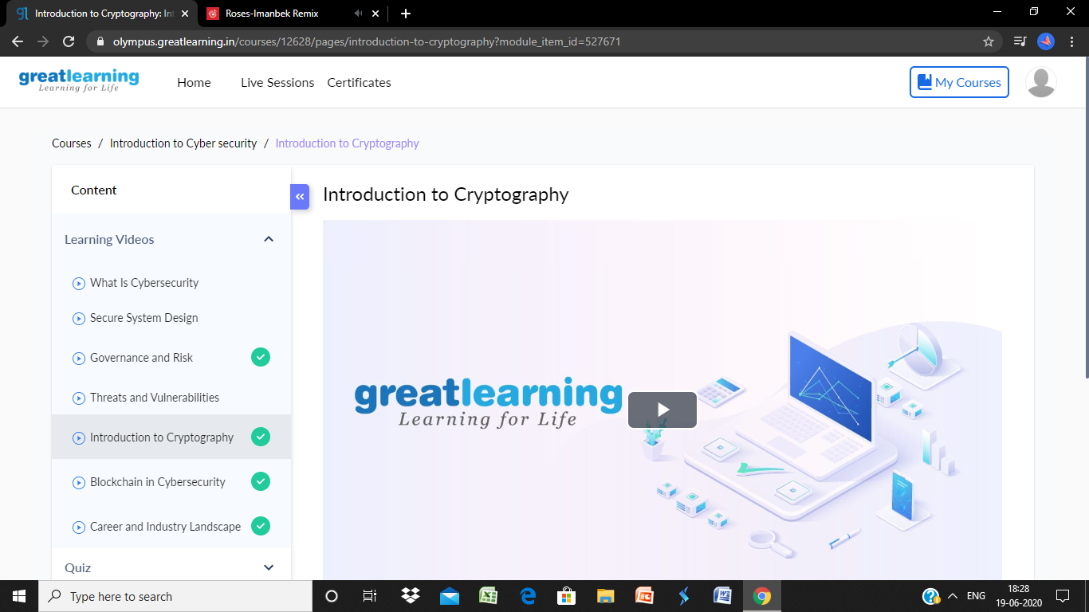

**Coding**

**Program 1**

**Python program to convert first and last letter of string to Upper-Case**

String = input('Enter the String :')

String = String[0:1].upper() + String[1:len(String)-1] + String[len(String)-1:len(String)].upper()

print(String)